**CHAPTER-4**

**SYSTEM DESIGN**

**Use case Diagram:**

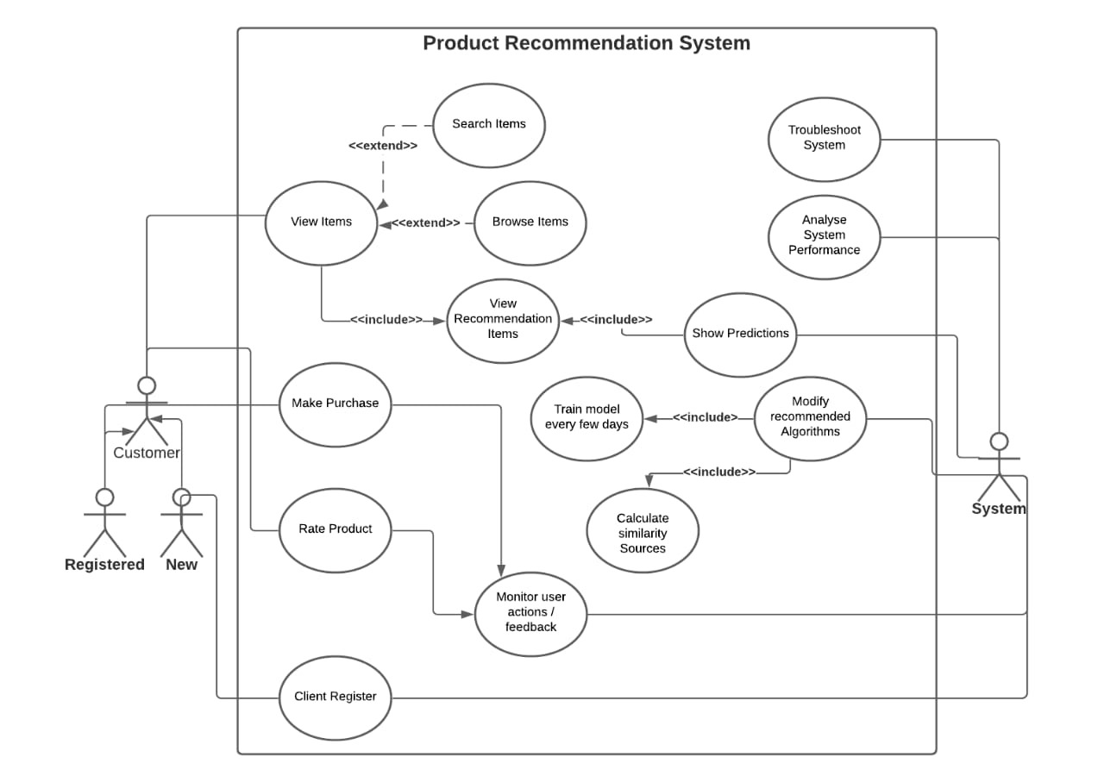

**Use case Diagram**

**Class Diagram:**

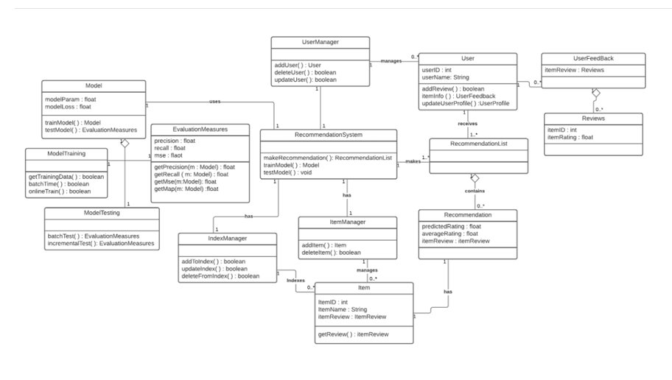

**Sequence Diagram:**

